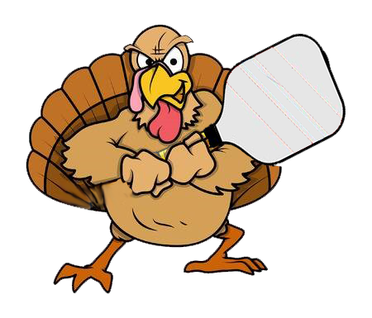­

**Tournament Information**

***Divisions:*** **Men’s, Women’s (11/16) and Mixed Doubles (11/17): 3.5, 4.0, 4.5, 5.0+**

***Prizes:******Cash payout for 1st & 2nd of the 5.0 divisions; Medals for1st-3rd in the 3.5-4.5 divisions***

***Registration:*** [**http://pickleballtournaments.com/**](http://pickleballtournaments.com/)

**Any questions?? Jane Cech** [**jcech3320@gmail.com**](mailto:jcech3320@gmail.com) **/ (402) 318-2151**

**Joel Houston** [**joelhouston@yahoo.com**](mailto:joelhouston@yahoo.com) **/ (402) 429-2438**

***Register early, entries are limited***

**Sponsored by Foster Care Closet/Foster Care Haven, Pickleball Lincoln, and Lincoln Surgical Hospital**

**Genesis Racquet Club**

**5300 Old Cheney Rd.**

**Lincoln NE 68516**

**Saturday & Sunday**

**November 16th & 17th, 2019**

**Turkey Shootout**

PickleballTournament