Pickleball Lincoln, Inc.
Established June 2017
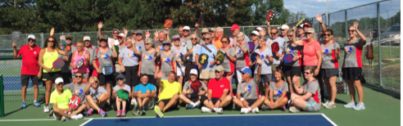

On July 1, 2017, Pickleball Lincoln will become an Official Club.
Officers: Mark Nelson, Bill Roehrs, Jane Cech, Ann Heermann

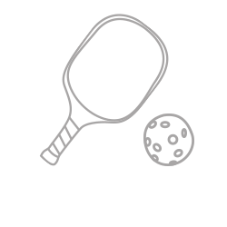
Board Members: Mark Nelson, Bill Roehrs, Jane Cech, Ann Heermann, Gale Breed,
Mike Magnuson, Joel Houston, and Rosalie Duffy

Become a member and enjoy these benefits:
1. Free liability insurance coverage for members year round
2. Reduced fees for Pickleball Lincoln, Inc. and local tournaments
3. Lessons for small groups (Some clinics will have a registration fee)
4. Receive member communications through Track it Hub
5. Club organized round robins, ladders, and social gatherings
6. Places 2 Play – locations and schedules for indoor and outdoor pickleball

Pickleball Lincoln, Inc. is a non-profit 501(c)(3) corporation, all donations are tax-deductible. Donations, member dues and fundraisers go 100% toward expanding and improving the sport of pickleball in Lincoln.

Membership dues are collected every May/June for $15.00 per person; you can join at any time. Any extra donated money is used for facility enhancements and play expansion; your generous support of pickleball in Lincoln is greatly appreciated!
_________________________________________________________________________________________________________________________

Please complete the registration form and mail cash or check to:
Mike Magnuson
7450 Upton Grey Lane
Lincoln NE 68516
Make checks payable to Pickleball Lincoln, Inc.

Name___________________________________________ Email______________________________ _____

Address Phone number

